DEPT. OF ELECTRICAL & ELECTRONICS ENGINEERING

SRM INSTITUTE OF SCIENCE AND TECHNOLOGY, Kattankulathur – 603 203

|  |  |
| --- | --- |
| Title of Experiment | : **3**.**Transient analysis of Series RL, RC circuits** |
| Name of the candidate | : Debarghya Barik |
| Register Number | : RA2011026010022 |
| Date of Experiment | : 28.10.2020 |

|  |  |  |  |
| --- | --- | --- | --- |
| Sl.  No. | Marks Split up | Maximum marks  (50) | Marks obtained |
| 1 | Pre Lab questions | 5 |  |
| 2 | Preparation of observation | 15 |  |
| 3 | Execution of experiment | 15 |  |
| 4 | Calculation / Evaluation of Result | 10 |  |
| 5 | Post Lab questions | 5 |  |
|  | **Total** | **50** |  |

Staff Signature

**PRE LAB QUESTIONS**

1. **Define Transient and classify**

**Ans:**

A transient event is a short-lived burst of energy in a system caused by a sudden change of state. It is the response of circuit due to sudden application of voltage or current. The source of the transient energy may be an internal event or a nearby event. The most common instance of the transient response in a circuit occurs when a switch is turned on or off.

Transients can be classified into two categories namely,

* Impulsive and
* Oscillatory.

These terms reflect the wave-shape of a current or voltage.

1. **Deduce the time constant for simple RL series circuit.**

**Ans:**

The time required for the current to flow in the RL series circuit to reach its maximum steady state value is equivalent to about 5 times constant or 5τ. This time constant τ, is measured by τ = L/R, in seconds, where R is the resistor value in ohms and L is the value of the inductor in henry.

1. **Deduce the time constant for simple RC series circuit.**

**Ans:**

The RC time constant is the measure that helps us to figure out how long it will take a capacitor to charge to a certain voltage level. It is equal to the product of the circuit resistance (in ohms) and the circuit capacitance (in farads), Τ = RxC (seconds). Generally, the time required to charge the capacitor, through the resistor, from an initial chare voltage of zero to approximately 63.2% of the value of the applied DC voltage.

1. **How will you design the values of L & C in a transient circuit?**

**Ans:**

After a long period of time, the current in the circuit will reach the "steady state" value of VB / R. Also at this same time, the derivative of the current with respect to time is approaching zero and hence the voltage drop across the inductor  VL = L(dl / dt) in this circuit approaches zero.

We have removed the power source from the RL circuit and the inductor will now "drain" through the resistor. With the battery removed, we can now rewrite to get the following.

0 = *VR* + *VL* = *IR* + (dI/dt)L

|  |
| --- |
|  |
|  |

*L*

Solving again for *I*(*t*) using

|  |
| --- |
| *τL* =  L/R |
|  |

 we find

*I*(*t*) = *Ioe*−*t*/*τL*.

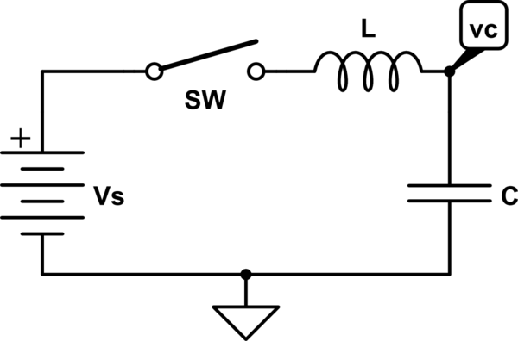

|  |  |
| --- | --- |
| **Experiment No. 3 Date :** | **Transient analysis of series RL, RC circuits** |

**Aim:**

To obtain the transient response and measure the time constant of a series RL and RC circuit for a pulse waveform.

**Apparatus Required:**

|  |  |  |  |
| --- | --- | --- | --- |
| Sl. No. | Apparatus | Range | Quantity |
| 1 | Function Generator | 800 Hz | 1 |
| 2 | Inductor | 1 mH | 1 |
| 3 | Resistor | 4 KΩ | 1 |
| 4 | Capacitor | 1 nF | 1 |
| 5 | Bread Board & Wires | -- | Required |
| 6 | CRO |  | 1 |
| 7 | CRO Probes |  | 2 |

**Theory**

In this experiment, we apply a pulse waveform to the RL or RC circuit to analyze the transient response of the circuit. The pulse-width relative to a circuit’s time constant determines how it is affected by an RC or RL circuit.

Time Constant (τ): A measure of time required for certain changes in voltages and currents in RC and RL circuits. Generally, when the elapsed time exceeds five time constants (5τ) after switching has occurred, the currents and voltages have reached their final value, which is also called steady-state response.

The time constant of an RC circuit is the product of equivalent capacitance and the Thevenin’s resistance as viewed from the terminals of the equivalent capacitor. τ = RC

A Pulse is a voltage or current that changes from one level to the other and back again. If a waveform’s high time equals its low time, as in figure, it is called a square wave. The length of each cycle of a pulse train is termed its period (T). The pulse width (tp) of an ideal square wave is equal to half the time period.

**Procedure for RL:**

1. Make the connections as per the circuit diagram.
2. Choose square wave mode in signal generator
3. Using CRO, adjust the amplitude to be 2 volts peak to peak.
4. Take care of the precaution and set the input frequency.
5. Observe and plot the output waveform.
6. Calculate the time required by the output to reach 0.632 times the final value (peak).
7. This value gives the practical time constant. Tabulate the theoretical and practical values.

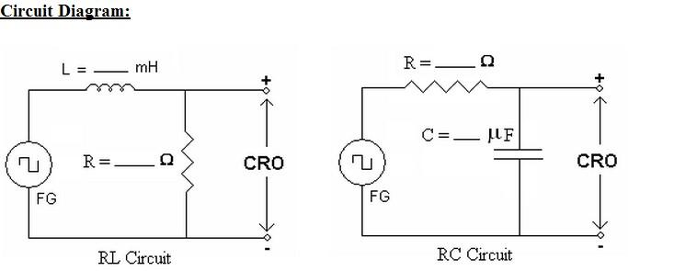

**E – Circuit Diagrams:**

**RL Circuit:**

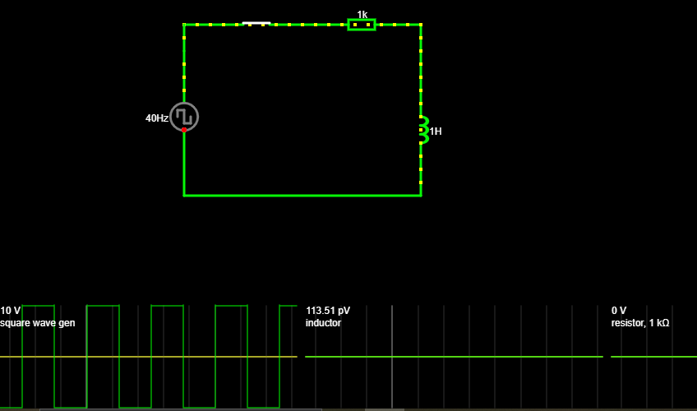

**RC Circuit:**

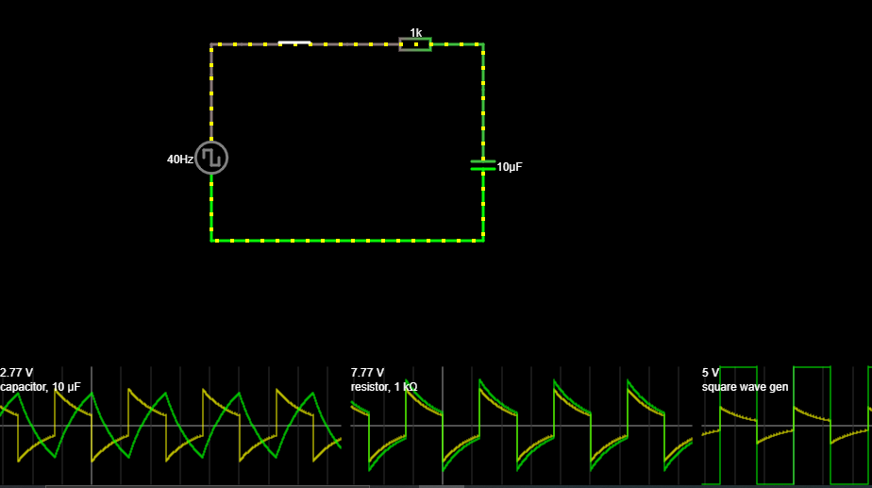

**Equivalent Circuit Diagram:**

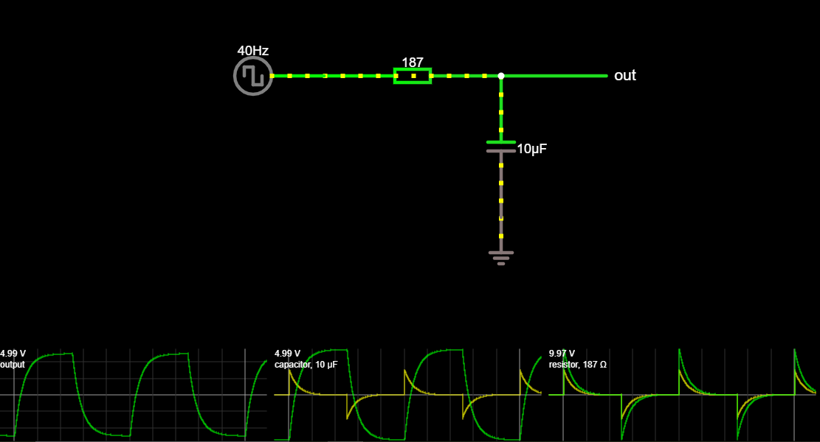

**Model Graph:**

1. **RL Transient :Output voltage across Resistor:**

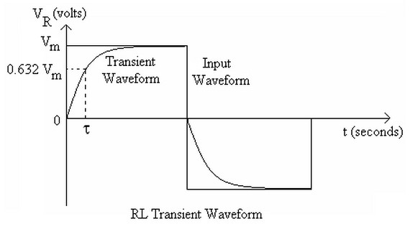

1. **RC Transient :Output voltage across Capacitor:**

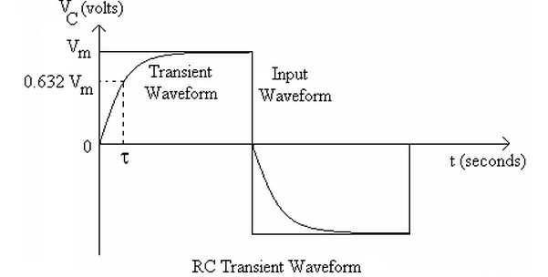

**Hardware setup:**

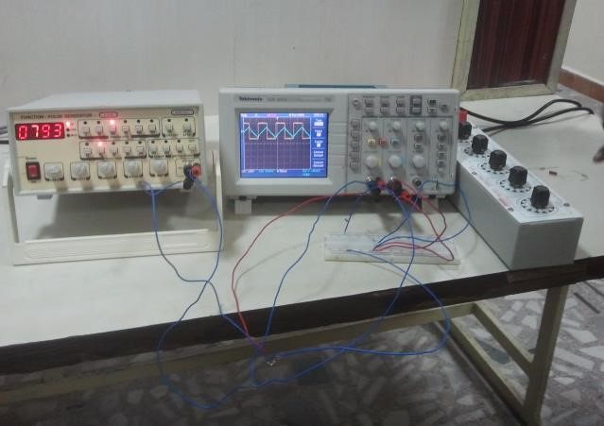 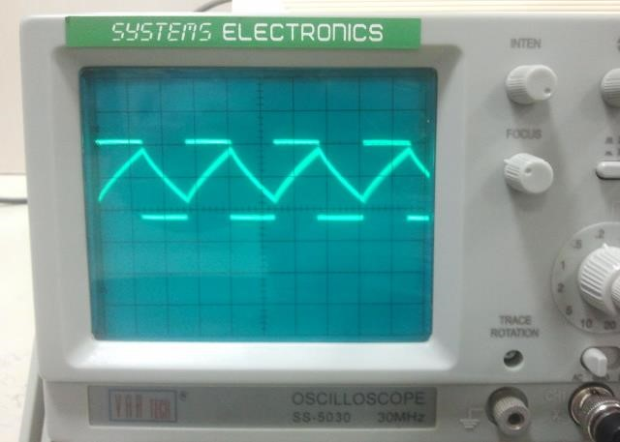

**RC Transient Waveform Graph:**

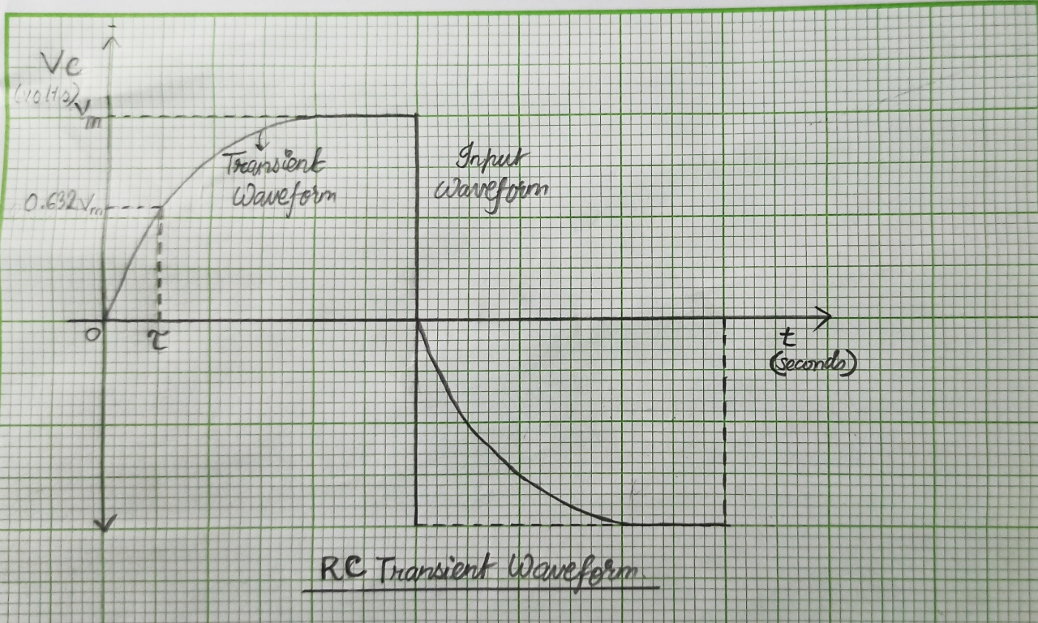

**RL Transient Waveform Graph:**

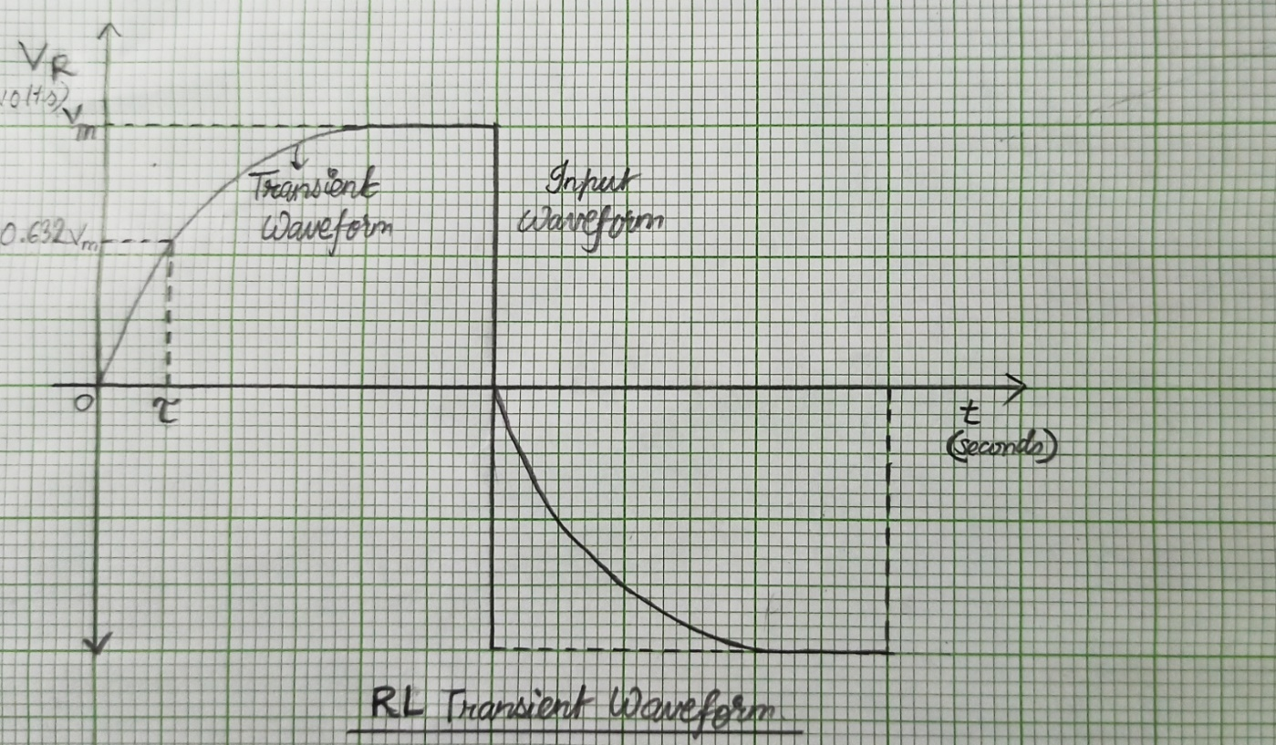

**Result:**

With the transient analysis we saw that the practical and theoretical values of time constant of RL and RC are approximately similar. It is clearly visible from the graph that the capacitor or inductor takes some time to charge or discharge, and eventually settles on its new steady state. We call the response of a circuit immediately after a sudden change the transient response, in contrast to the steady state.

**POST LAB QUESTIONS**

1. **Why it is necessary to discharge the capacitor every time you want to record another transient voltage across the capacitor?**

**Ans:**

A charged capacitor left by itself will retain the charge for even months or years. So, when it is disconnected from supply, the instant voltage it carries across terminals is maintained, which could often be dangerous.

So, before you handle a disconnected capacitor, it is very essential to discharge it to remove all charge and corresponding voltage. It is usual to discharge it through a resistor first, and then short the terminals directly to bring the voltage to zero.

1. **If the capacitor remains charged, what would you expect to see across the capacitor when you re-close the switch to try to record another transient?**

**Ans:**

When a capacitor is fully charged, no current flows through it, so if somebody tries to record a transient, he would see no change in capacitor, i.e. he won't see any change in the capacitor so transient would be recorded. If one wants to get the transient value one should use a discharged capacitor.

1. **Give the expression for energy stored in the capacitor?**

**Ans:**

Energy ( E )= Q2 / 2C

= CV2 / 2

​ = QV / 2

Where: C = capacitance of capacitor​

**Q = charge stored in capacitor**

**V = potential difference across the terminals.**

1. **Draw the discharge of capacitor voltage with time in RC circuit?**

**Ans:**

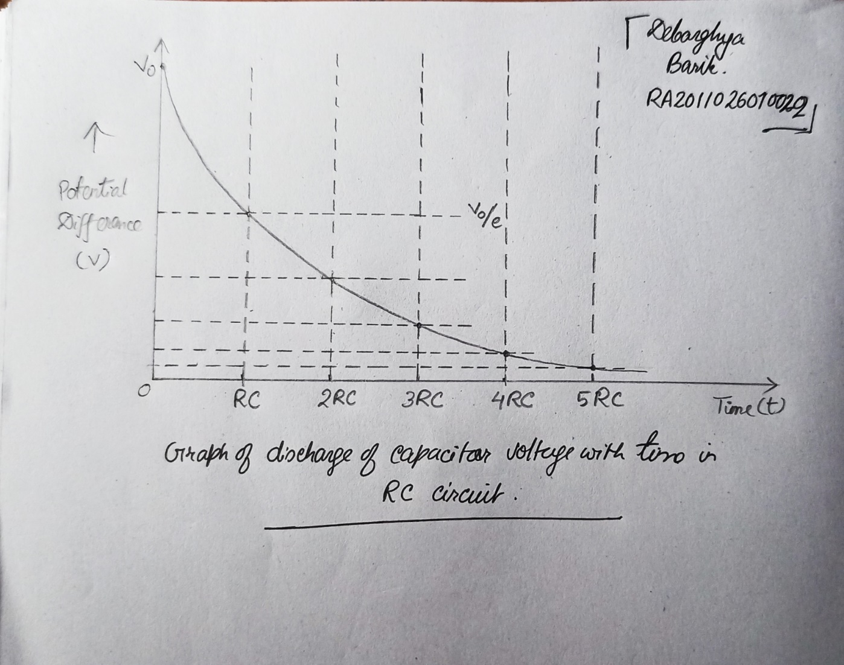

**Discharge of capacitor voltage with time in RC circuit**

1. **What do you understand from the value of time constants (RL, RC)?**

Ans:

The**RL** time constant indicates the amount of time that it takes to conduct 63.2% of the current that results from a voltage applied across an inductor.

The **RC** time constant is a measure that helps us figure out how long it will take a cap to charge to a certain voltage level.

--------------------------------------------------------------------------------------------------------------